Finance Investigation

Introduction
The aim of this investigation is to compare investment and loan options using simple interest calculations. The investigation looks at a hypothetical scenario where the Student Representative Council is looking to purchase a new covered seating area.
In the first task, four different investment options, all accruing simple interest over a 5 year period, are compared to determine the most favorable option. In the second task, three loan options are compared. The third task explores the effect that compounding interest has on an investment.
Throughout the investigation, the following formula for calculating simple interest is used
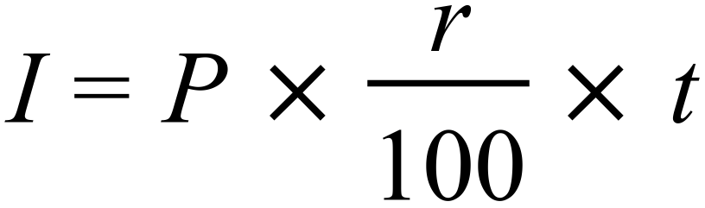
where I is the interest earned/paid, P is the principal amount, r is the interest rate per unit of time and t is the number of time units.

Task 1: Comparing investment options
In this task the four investment options shown in Table 1 are compared. The principal is $6000 for each option. For each option, the interest paid over 5 years is calculated. The interest is added to the original investment, and any annual fees are deducted to determine the final value of the investment after 5 years.
OPTION 1 | 6% per annum | No fees charged
OPTION 2 | 7% per annum | $50 annual fee
OPTION 3 | 3.2% per half year | No fees charged
OPTION 4 | 0.8% per month | $5 per month
Table 1: Investment options
For the first option:
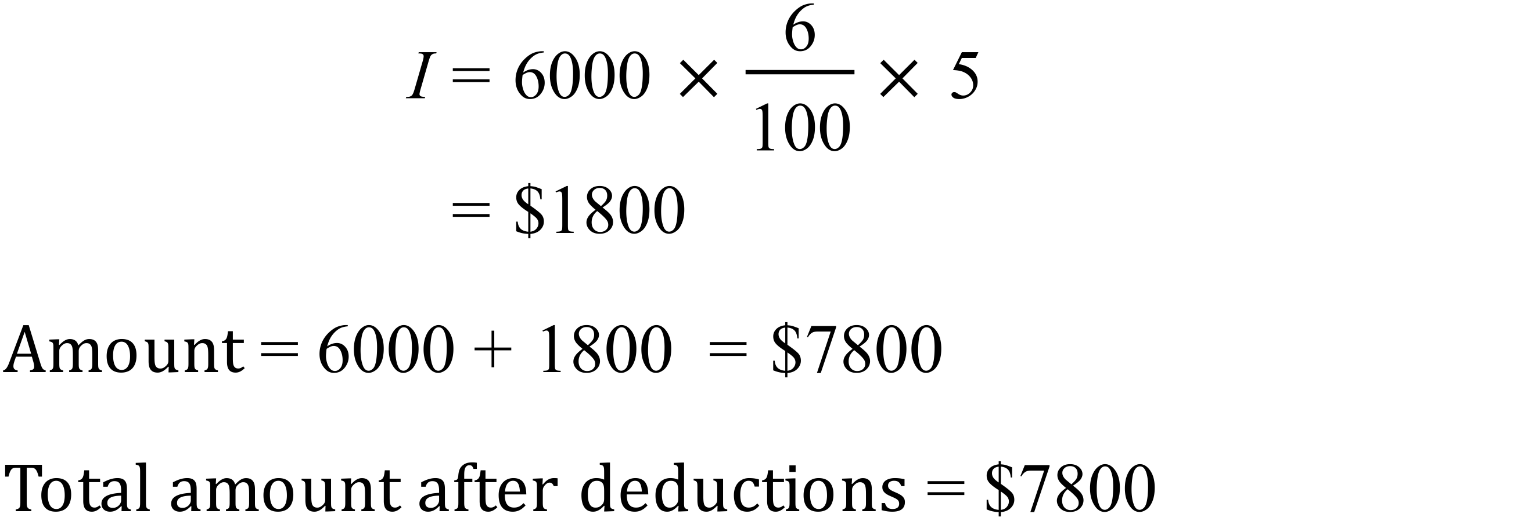

For the second option:
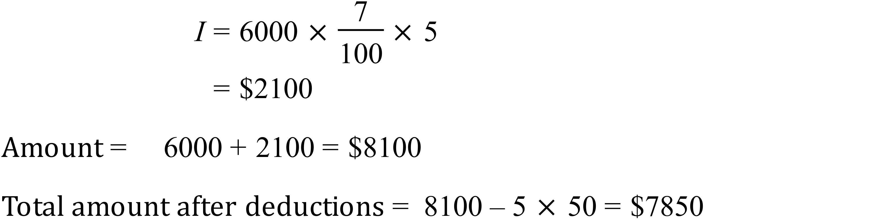
For the third option:
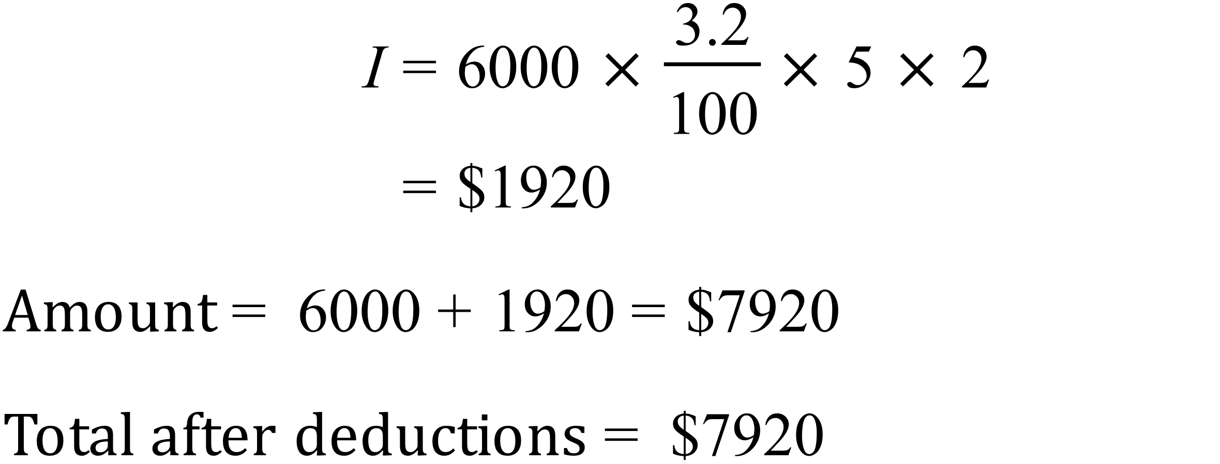
For the fourth option:
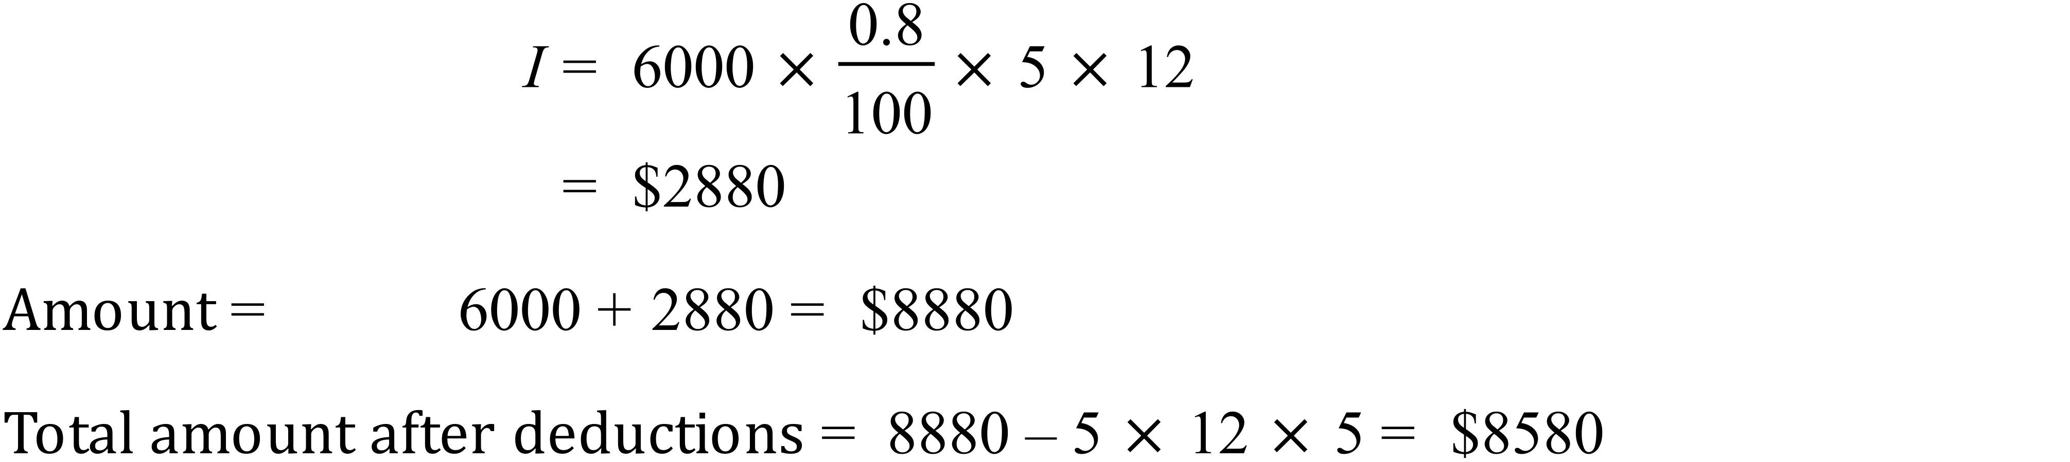

The results for the four different investment options are summarized in Table 2. From the table it is clear that option 4 is the best investment option since it returns the most amount of money over the five year period after fees have been deducted. This is despite the fact that it also incurs the highest amount of fees.
Option | Interest | Total (before deduct) | Deductions | Total (after deduct)
OPTION 1 | $1800 | $7800 | $0 | $7800
OPTION 2 | $2100 | $8100 | $250 | $7850
OPTION 3 | $1920 | $7920 | $0 | $7920
OPTION 4 | $2880 | $8880 | $300 | $8580
Table 2: Summary of investment calculations

To determine how long it would take to earn $1000 interest using investment option 1, the simple interest formula is rearranged to make investment time the subject of the equation, i.e.
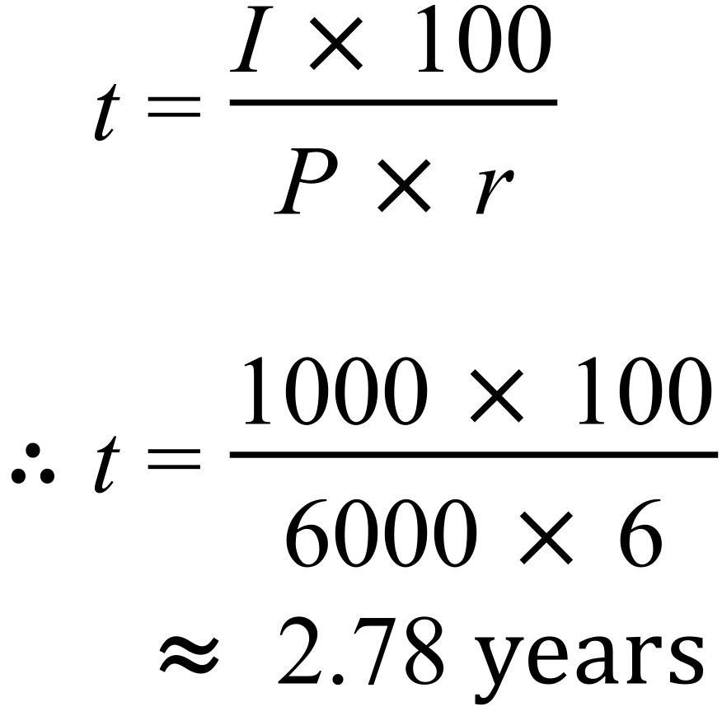
It would therefore take 3 years (assuming that interest is paid annually) or 2 years and 9 months (if interest is paid monthly) to earn $1000 in interest.
To determine what interest rate would be required to earn $2000 over 10 years, assuming a principal of $6000, the simple interest formula is rearranged to make the interest rate the subject of the equation, i.e.
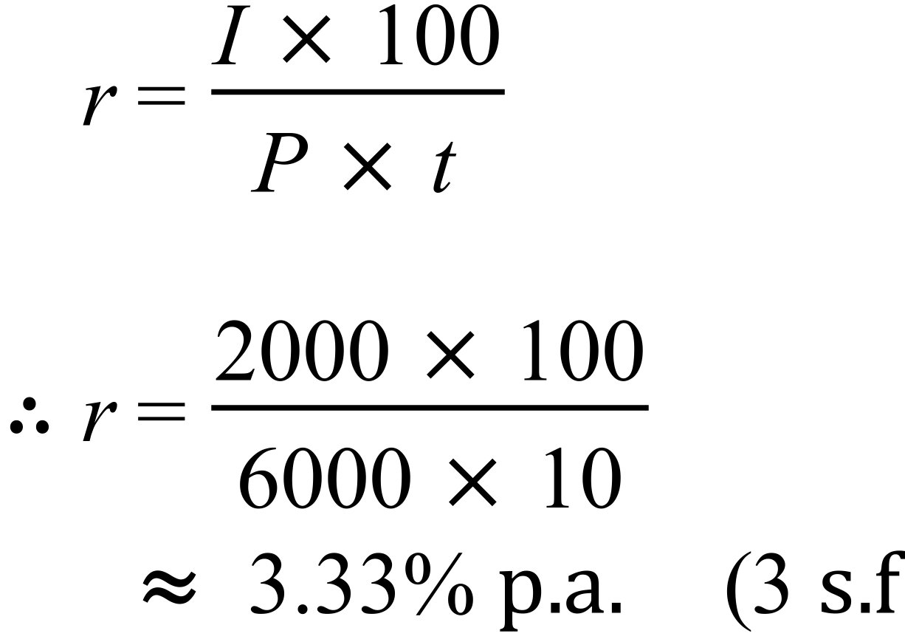
A rate of 3.33% p.a. is significantly lower than the rates given in the other investment options, so would not be preferable in comparison to these. However, given the current Reserve Bank interest rate, it would be deemed to be very reasonable.

Task 2: Comparing loan options
For this task, the three loan options shown in Table 3 are compared using the simple interest formula. For each option, a starting principal of $9000 is assumed, since the SRC needs a total of $15000 and already has $6000 ( 15000-6000=9000).
OPTION 1 | 8% per annum | To be paid back over 10 years
OPTION 2 | 7% per annum | To be paid back over 12 years
OPTION 3 | 0.5% per month | To be paid back over 15 years
Table 3: loan options
For option 1:
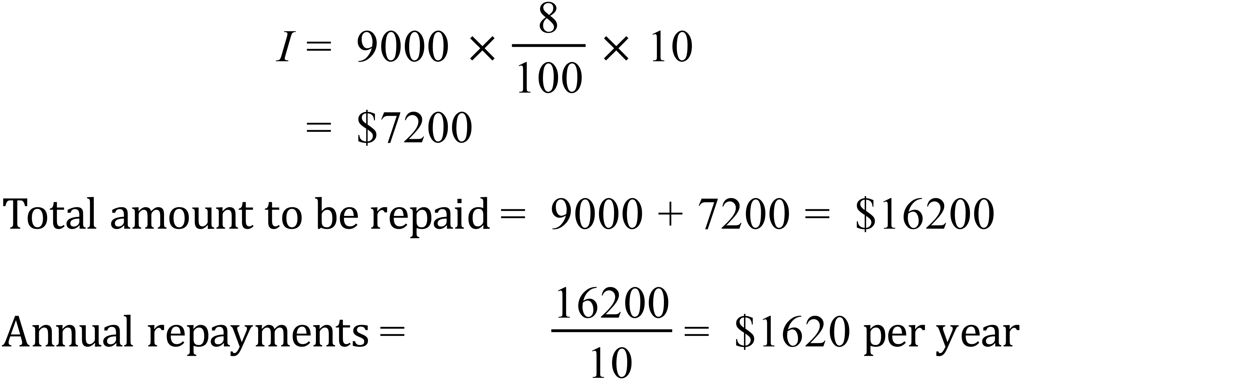
For option 2:
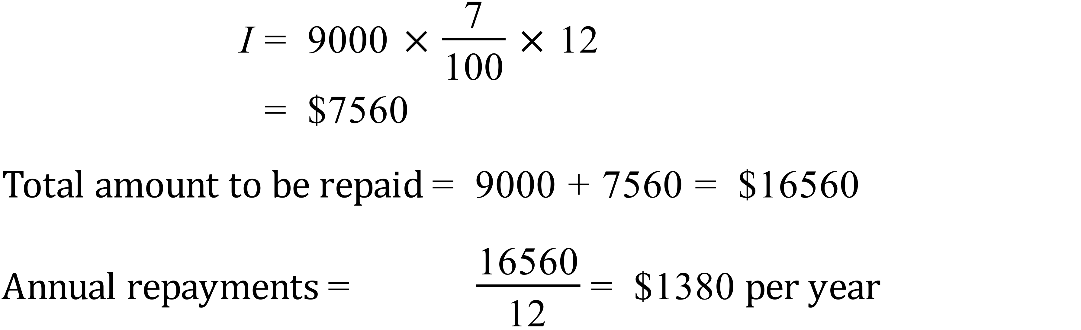
For option 3:
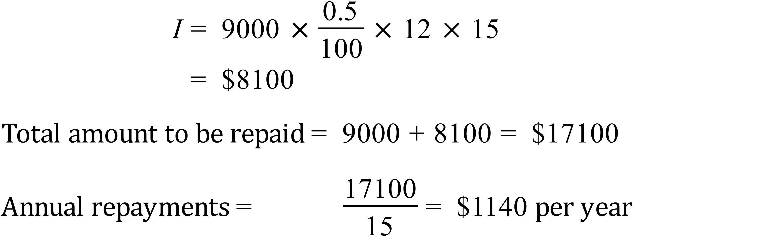
Of the three options, option 1 requires the least amount of interest to be repaid. However Option 3 has the smallest annual repayment rate. If the SRC can afford the higher annual repayments that would be advised to go with option 1 to minimize the amount of accumulated interest. However if they wish to minimize their annual repayments and are willing to pay slightly more interest, Option 3 would be the best option.

Task 3: Compound interest
In this task, it is assumed that interest is compounded annually, therefore meaning that interest will be earned on interest. To calculate the amount of compound interest earned over 5 years, the simple interest formula is initially used, starting with a principal of $6000 and an interest rate of 6% compounded annually:
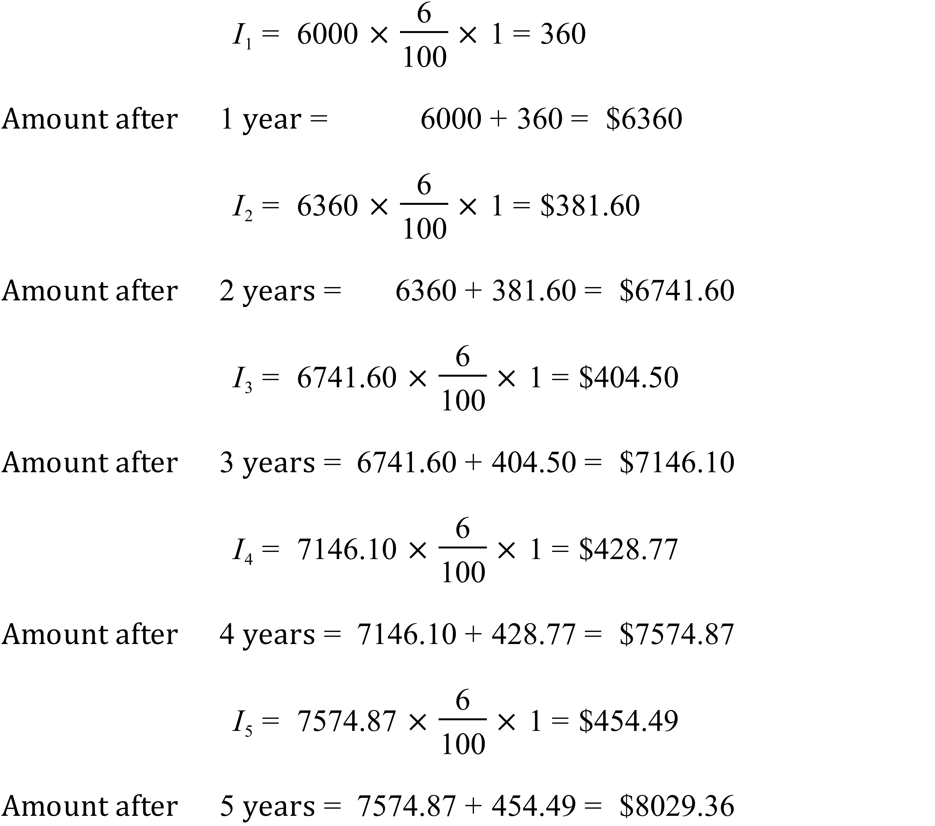
With compound interest the SRC would earn $229.36 more that it would with simple interest calculations. The reason why this option is more favourable is because the interest from the previous years is added to the principal for the current year. So in effect the principal amount increases each year, thus increasing the amount of interest that can be earned.
Using the compound interest formula:
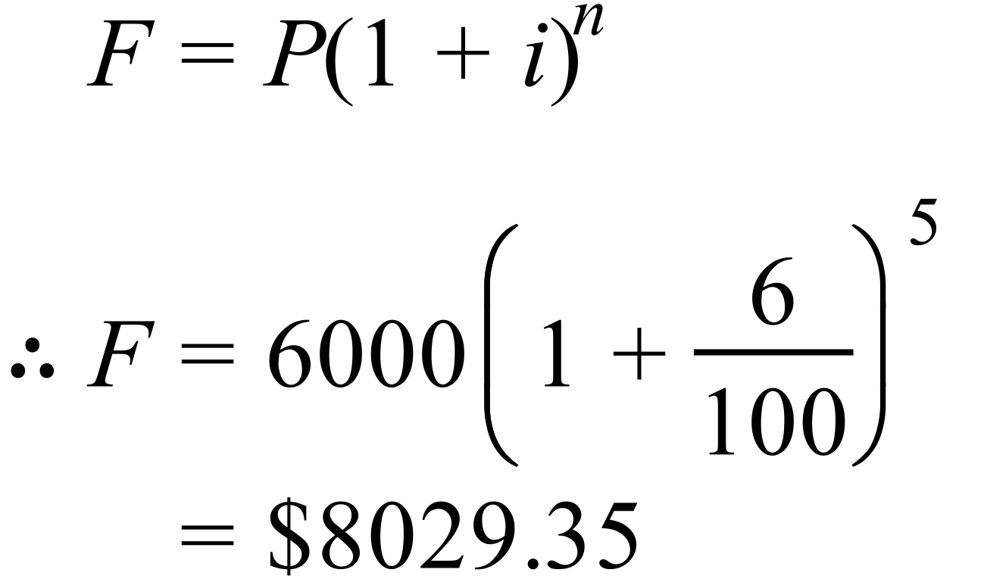

This is (approximately) the same as the amount calculated above. The 1c difference is most likely due to rounding errors. Using the compound interest formula is clearly easier and quicker than calculating interest one year at a time. This would be more so when calculating interest over 30 years.

Conclusions
In this investigation, the simple interest formula was used to compare investment and loan options. In task 1 it was found that fourth option was best, since it provided the greatest return, despite charging the highest fees. In task 2 it was determined that the best loan option depends on how much you can afford to repay per year. Higher annual repayments can lead to smaller amounts of accumulated interest. In task 3 it was clearly shown that for investments, options that provide compound interest are better, providing higher returns over the same time period.

